Linux Commands
Here’s a list of basic Linux commands that are commonly used:
File and Directory Management
- ls - List directory contents.
  - Example: ls -l (detailed listing), ls -a (show hidden files).
- cd - Change directory.
  - Example: cd /path/to/directory.
- pwd - Print the current working directory.
- mkdir - Create a new directory.
  - Example: mkdir new_folder.
- rmdir - Remove an empty directory.
- rm - Remove files or directories.
  - Example: rm file.txt, rm -r folder (remove directory recursively).
- cp - Copy files or directories.
  - Example: cp source.txt destination.txt.
- mv - Move or rename files or directories.
  - Example: mv old_name new_name.
- touch - Create a new empty file.
  - Example: touch file.txt.
File Viewing
- cat - View file contents.
  - Example: cat file.txt.
- more - View file contents page by page.
- less - Similar to more, but allows backward navigation.
- head - Display the first lines of a file.
  - Example: head -n 10 file.txt.
- tail - Display the last lines of a file.
  - Example: tail -n 10 file.txt.
- nano, vi, vim - Text editors.
File Permissions
- chmod - Change file permissions.
  - Example: chmod 755 file.txt.
- chown - Change file ownership.
  - Example: chown user:group file.txt.
Process Management
- ps - View running processes.
  - Example: ps aux.
- top or htop - Display real-time system processes.
- kill - Terminate a process by PID.
  - Example: kill 1234.
- killall - Kill processes by name.
  - Example: killall firefox.
Disk Usage
- df - Display disk space usage.
  - Example: df -h (human-readable format).
- du - Show directory size.
  - Example: du -sh folder.
Networking
- ping - Check connectivity to a host.
  - Example: ping google.com.
- curl - Transfer data from or to a server.
  - Example: curl http://example.com.
- wget - Download files from the web.
  - Example: wget http://example.com/file.txt.
- ifconfig or ip - Display network interfaces.
  - Example: ip addr.
Searching
- find - Search for files and directories.
  - Example: find /path -name "*.txt".
- grep - Search within files.
  - Example: grep "text" file.txt.
Compression
- tar - Archive files.
  - Example: tar -cvf archive.tar file.txt.
- gzip, gunzip - Compress and decompress files.
  - Example: gzip file.txt.
System Information
- uname - Display system information.
  - Example: uname -a.
- whoami - Display the current user.
- uptime - Show system uptime.
- free - Display memory usage.
  - Example: free -h.
User Management
- who - Show who is logged in.
- adduser, useradd - Add a user.
- passwd - Change a user's password.
Others
- echo - Display a line of text.
  - Example: echo "Hello, World!".
- history - Display command history.
- clear - Clear the terminal screen.
- exit - Log out or close the terminal session.

Find Installed Software
Check Ports
lsof -i
Issue : If your Jenkins server installed on virtualbox you are unable to access on any computer on same network
If VM OS is Linux then run below command:
$sudo ufw status
Output: Status: Inactive
$systemctl status ufw
$systemctl start ufw
$systemctl enable ufw
$sudo ufw allow sshd
$sudo ufw status
Output :
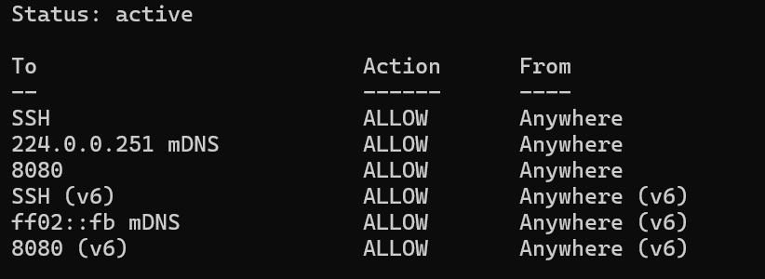

If UFW is not install then install from below command and then perform above steps:
$yum install -y epel-release
$yum install -y ufw
Docker Installation and setup:
Remove complete docker from machine : it might report that you have none of these packages installed.
Images, containers, volumes, and networks stored in /var/lib/docker/ aren't automatically removed when you uninstall Docker.
$ sudo dnf remove docker \
docker-client \
docker-client-latest \
docker-common \
docker-latest \
docker-latest-logrotate \
docker-logrotate \
docker-engine

Install the dnf-plugins-core package (which provides the commands to manage your DNF repositories) and set up the repository.
$sudo dnf -y install dnf-plugins-core
$sudo dnf config-manager --add-repo https://download.docker.com/linux/centos/docker-ce.repo
Install:
$ sudo dnf install docker-ce docker-ce-cli containerd.io docker-buildx-plugin docker-compose-plugin

Enable docker service:
$sudo systemctl enable --now docker

Port Mapping:
docker run -p hostPort:containerPort image
ex: docker run -p hostPort:jenkinsServer container port
docker run -p hostPort:8090(Jenkins port)

